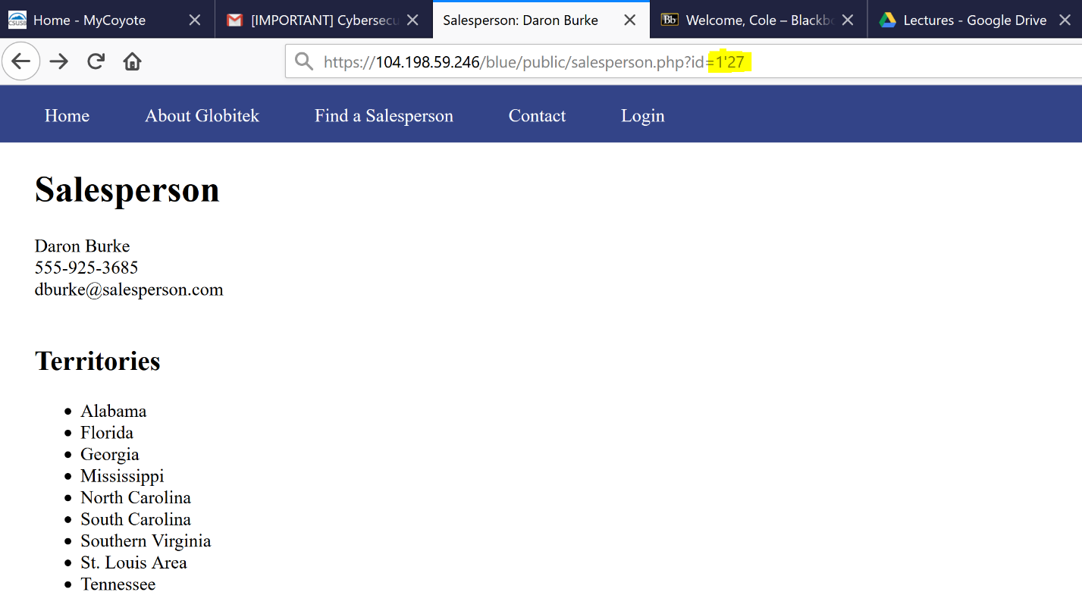

* Try a SQL injection into URL and see what show after enter.

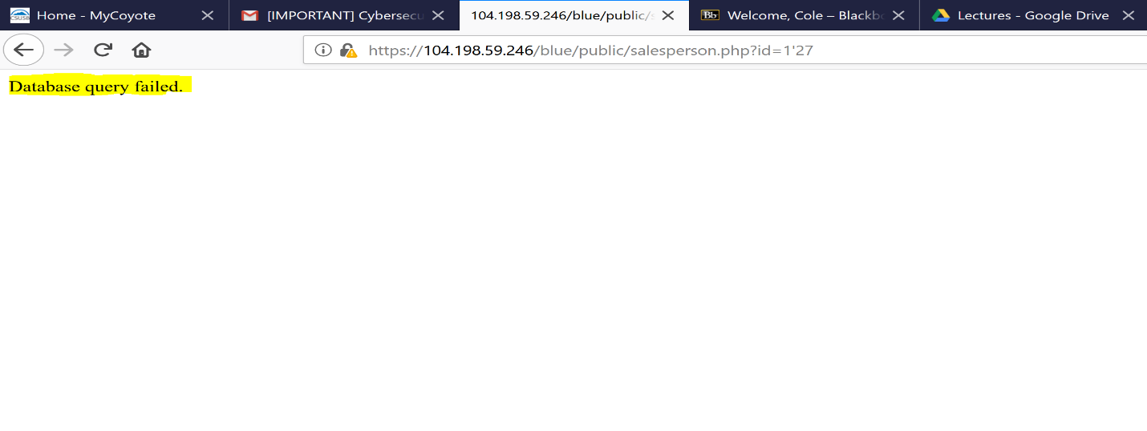

* The blue site will show SQL injection because you can see database query failed.
* Injecting ' OR SLEEP(5)=0--' or %27 into the URL will give you the following answer.

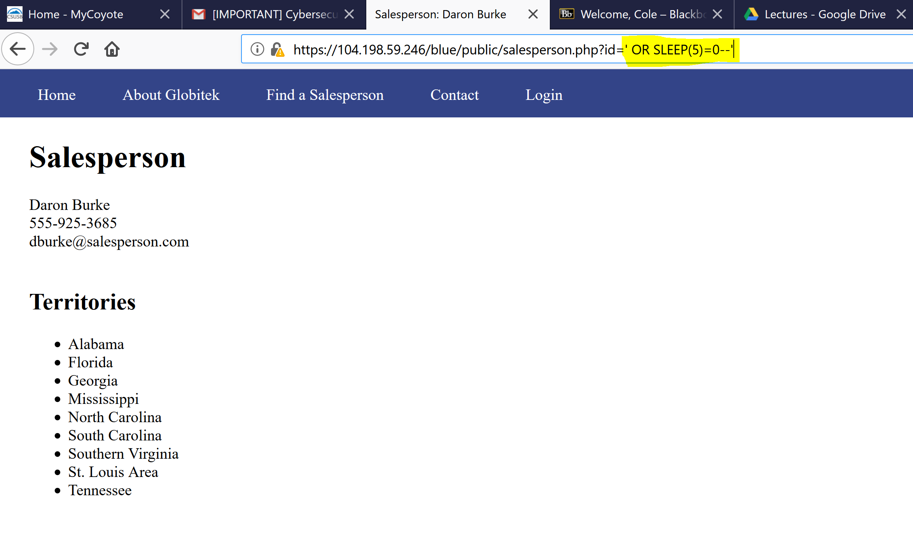

* The following ' OR SLEEP(5)=0--' will take you in the site without any issue.
* This vulnerability with in the code allow the user to access the database from the URL.
* By playing with URL or HTML you can injected SQL statement and find what you are looking for me.